DAY 28: Investigate C2 traffic
Summary: Today, I will investigate the Mythic C2 traffic through logs on Kibana <place holder>

Go to the RDP dashboard I just created on Day 22 and view the tables in this dashboard.

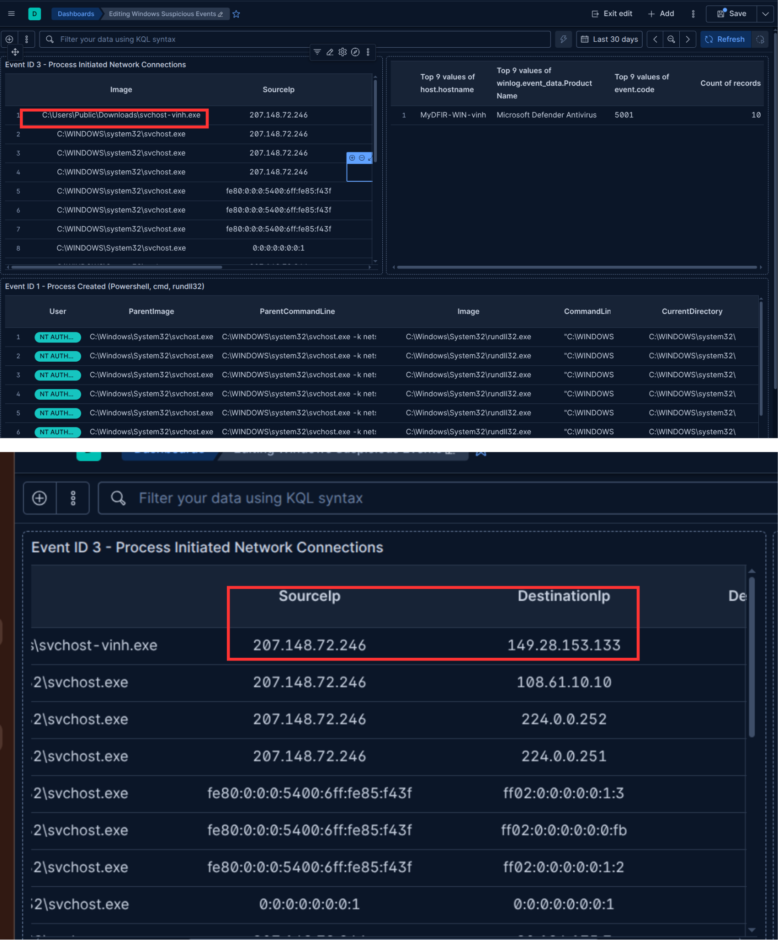
Figure 1: IOCs from the RDP activities dashboard
As we can see in the first line, we have a strange file name that is trying to connect to the public ip address 149.28.153.133.
There is also a connection that was initiated by powershell, it is connecting to this ip with non-standard port 8000. This is a sign for suspicious activity:
Figure 2: Connecting to strange ip through port 8000

Now, let’s go to search related activities associated with the IP:
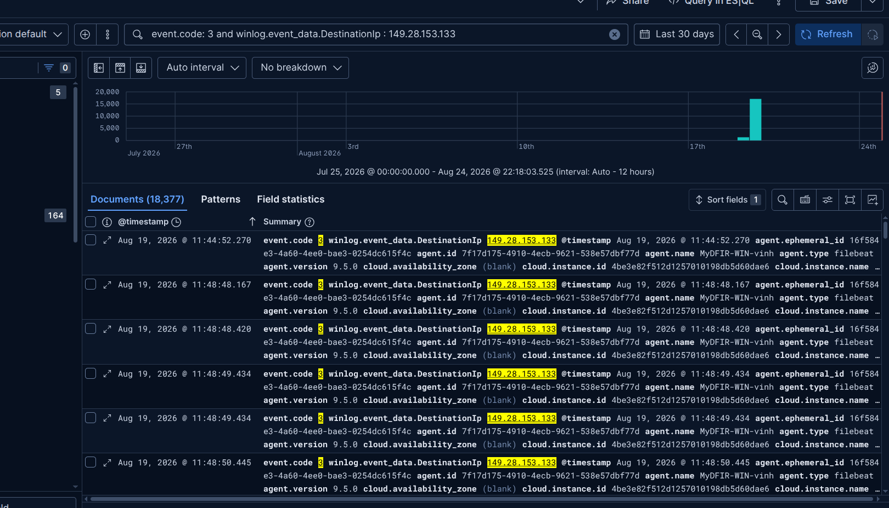
Figure 3: Network connection events associated with 149.28.153.133
I sorted the logs to display from oldest to newest events. So, the beginning event from this IP on my system is Timestamp: Aug 19, 2026 @ 11:44:52.270 - Network connection towards 149.28.153.133.

I’ll go to that event and analyze fields to extract and correlate important events:
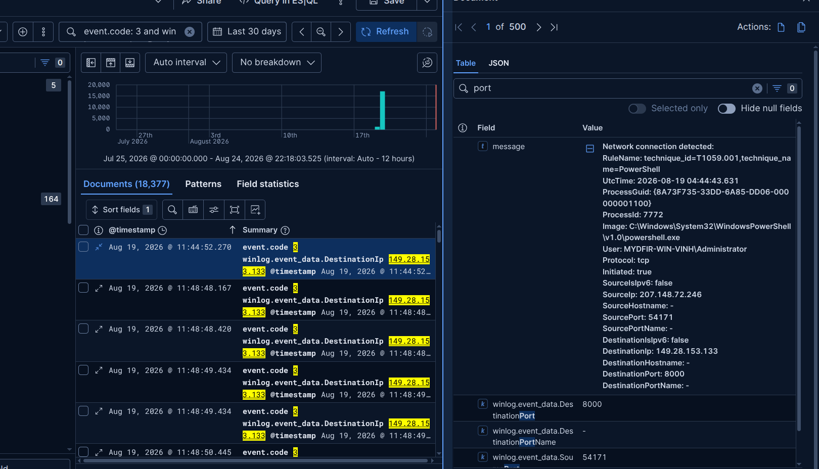
Figure 4: Analyzing the first event with destination IP 149.28.153.133

To track the full activities of a process that initiated a network connection, I will choose the processGuid field. A ProcessGUID is a globally unique identifier assigned to a running process, by monitoring and telemetry tools like Sysmon to make event correlation easier across a domain. Unlike a standard Process ID (PID), which is a short numeric value that can be recycled and reused by the operating system after a process exits or the system reboots, a ProcessGUID is completely unique and never reused during a process's lifetime [2].

=> From the starting point of the chain actions, I pick up the field ProcessGuid: {8A73F735-33DD-6A85-DD06-000000001100} to view the next actions from this process.
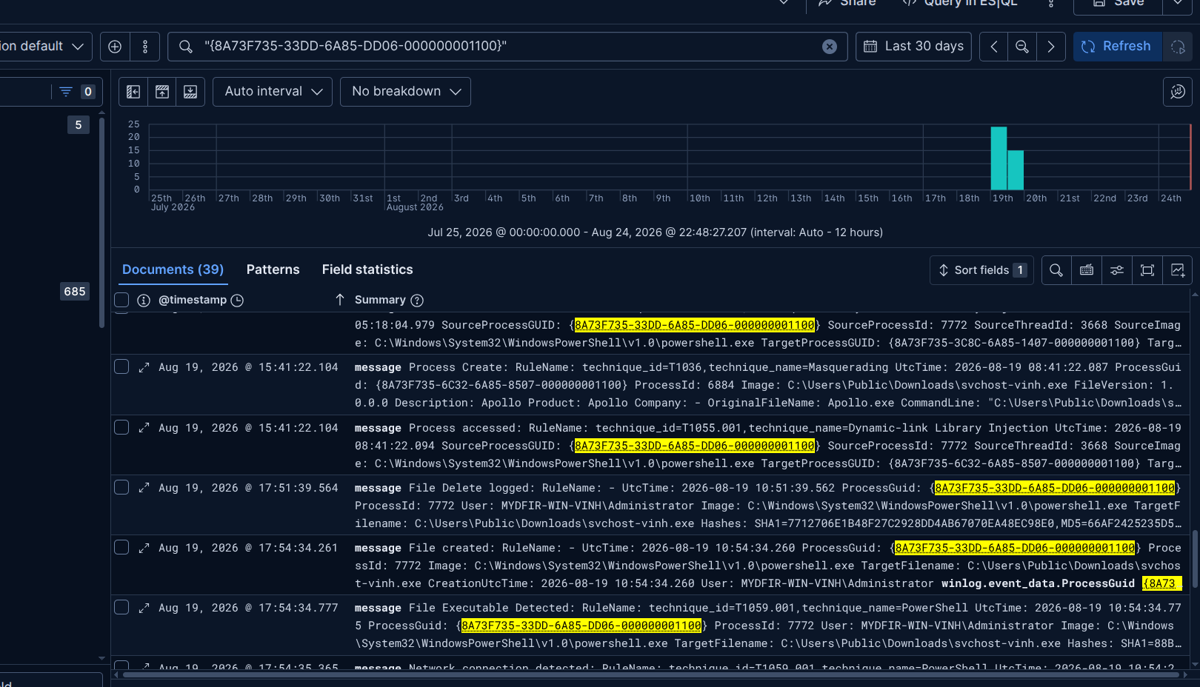
Figure 5: Filter out by processGUID
In the first event of the attack chain:

message | Process Create:  RuleName: technique_id=T1204, technique_name=User Execution  UtcTime: 2026-08-19 04:41:01.349  ProcessGuid: {8A73F735-33DD-6A85-DD06-000000001100}  ProcessId: 7772  Image: C:\Windows\System32\WindowsPowerShell\v1.0\powershell.exe  FileVersion: 10.0.26100.5074 (WinBuild.160101.0800)  Description: Windows PowerShell  Product: Microsoft® Windows® Operating SystemCompany: Microsoft CorporationOriginalFileName: PowerShell.EXE  CommandLine: "C:\Windows\System32\WindowsPowerShell\v1.0\powershell.exe"  CurrentDirectory: C:\WINDOWS\system32\User: MYDFIR-WIN-VINH\Administrator  LogonGuid: {8A73F735-C449-6A83-D052-460300000000}LogonId: 0x34652d0  TerminalSessionId: 2  IntegrityLevel: High  Hashes: SHA1=EB42621654E02FAF2DE940442B6DEB1A77864E5B,MD5=A97E6573B97B44C96122BFA543A82EA1,SHA256=0FF6F2C94BC7E2833A5F7E16DE1622E5DBA70396F31C7D5F56381870317E8C46,IMPHASH=AFACF6DC9041114B198160AAB4D0AE77  ParentProcessGuid: {8A73F735-C44F-6A83-A301-000000001100}ParentProcessId: 4464  ParentImage: C:\Windows\explorer.exe  ParentCommandLine: C:\WINDOWS\Explorer.EXE  ParentUser: MYDFIR-WIN-VINH\Administrator
The Sysmon recorded process creation in the 1st event, tree process structure is simply:
explorer.exe
└── powershell.exe
The next event: Sysmon Event ID 13 – Registry Value Set. This event indicates that a process wrote to/modified a value in Windows Registry.

Event ID: 13
EventType: SetValue
ProcessId: 7772
Image: C:\Windows\System32\WindowsPowerShell\v1.0\powershell.exe

PowerShell (PID 7772) |
└── write a Registry value

Besides that, we have several noise events like File Delete (Script policy testing on Windows OS) and Image Loaded - I verified the loaded modules for this process, and none of them is suspicious.
Scroll down to bottom and I caught a suspicious file creation event. This event has ID 11:
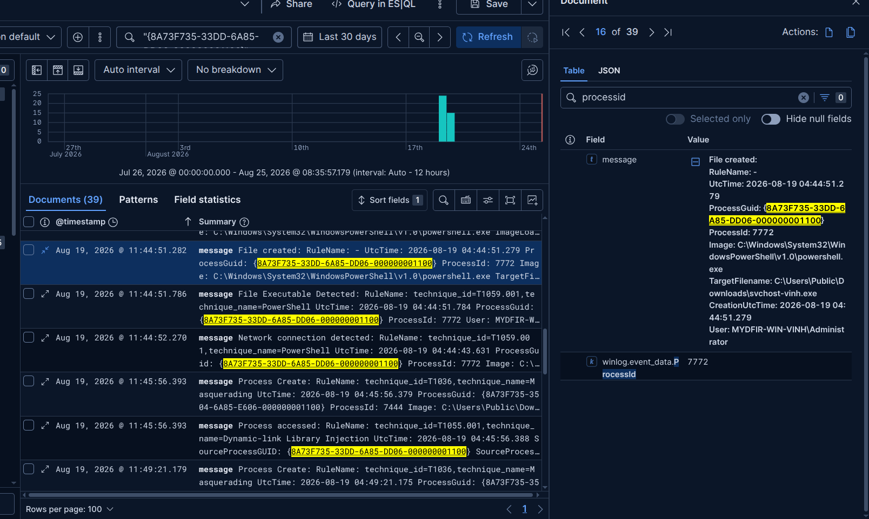
Figure 6: File installation event
As we can see in the figure 6, a file named svchost-vinh.exe was installed on the Windows machine by using the powershell tool.

I built a timeline table to track activities associated with the process with processGUID 8A73F735-33DD-6A85-DD06-000000001100
Timeline Table
Timestamp | Event
Aug 19, 2026 @ 11:44:51.282 | File Created: svchost-vinh.exe under folder “C:\Users\Public\Downloads\”
Aug 19, 2026 @ 11:44:51.786 | File Executable detected: C:\Users\Public\Downloads\svchost-vinh.exe
Aug 19, 2026 @ 11:44:52.270 | Network connection towards 149.28.153.133
Aug 19, 2026 @ 11:45:56.393 | Process Create:  CommandLine: "C:\Users\Public\Downloads\svchost-vinh.exe"  Created new process’s ProcessGuid: {8A73F735-35D1-6A85-F206-000000001100}

Next, I’ll search for activities that was executed by the new process:

*Note: Since the day 21 I executed the payload svchost-vinh.exe multiple times, so there will be a lot of process creation events on the Kibana. The exact process GUID we need to investigate:

Timestamp: Aug 19, 2026 @ 21:25:04.266
SHA1=88BF4519FBAC60B2A3BF6C0C03DF6A7B4C85B077
ProcessGuid: {8A73F735-BCC0-6A85-D108-000000001100}
ProcessId: 4896

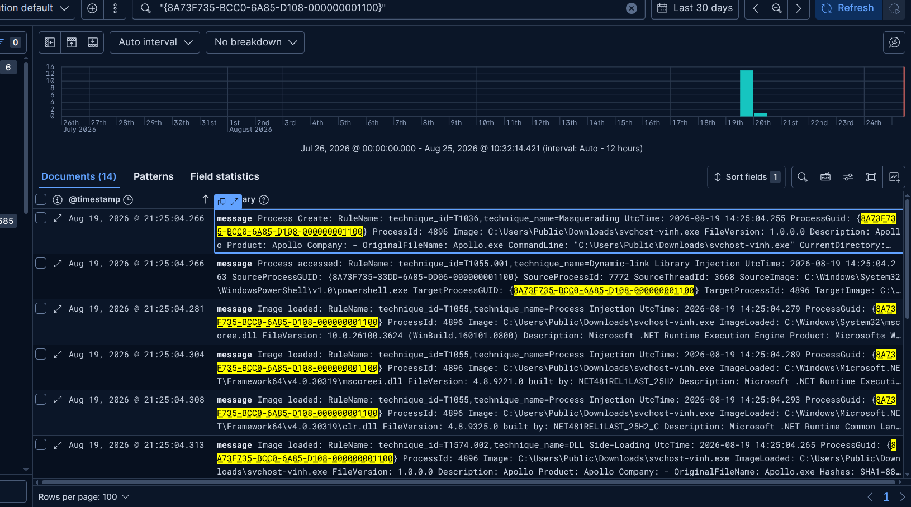
Figure 7: Activities of the process svchost-vinh.exe

Look into are there any child processes were spawned by svchost-vinh.exe:

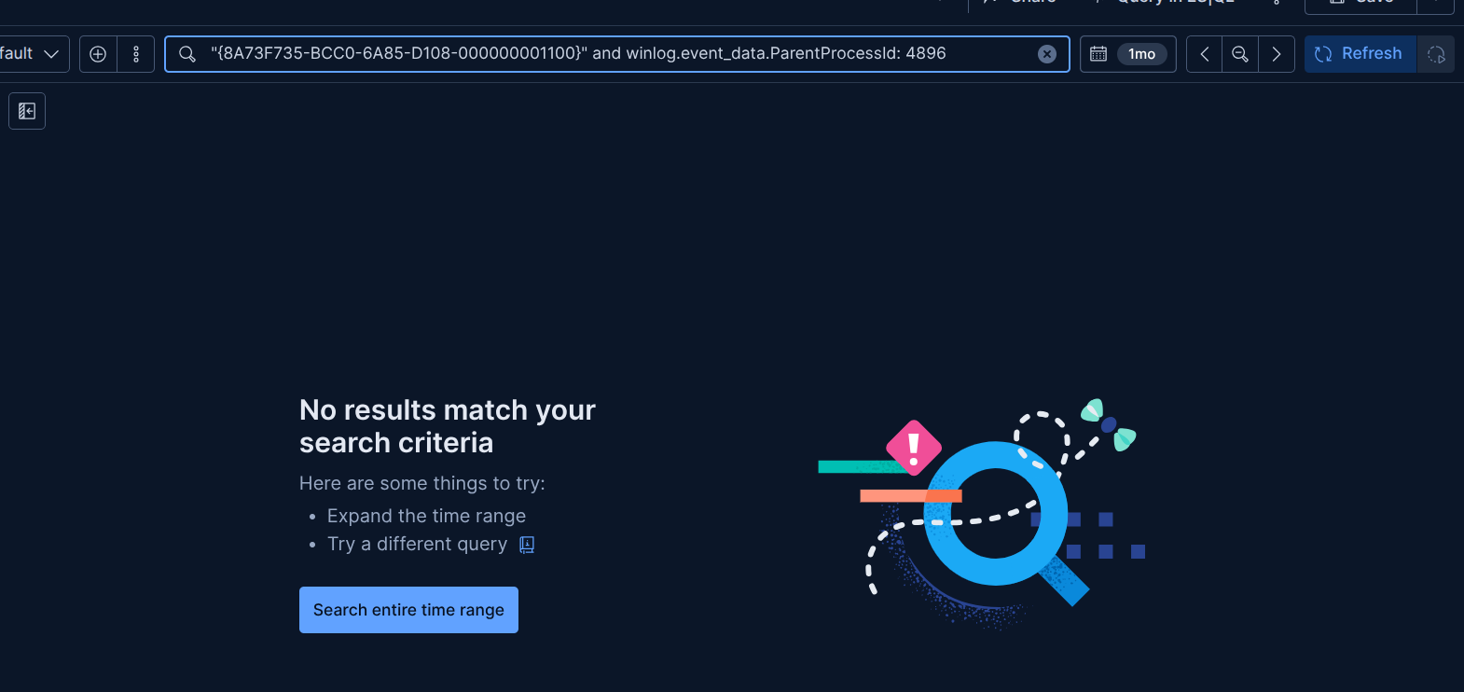
Figure 8: Searching for child processes were spawned by svchost-vinh.exe
There are no processes spawned by svchost-vinh.exe. Since the PID value is not reliable, a PID can be released when a process terminates and then assigned to another process. Therefore, the best way to search for events related to svchost-vinh.exe is to use the ParentProcessGuid field.

I will search for the terms passwords.txt on the search bar, this is a little trick to search events related to accessing known files from the malicious process.
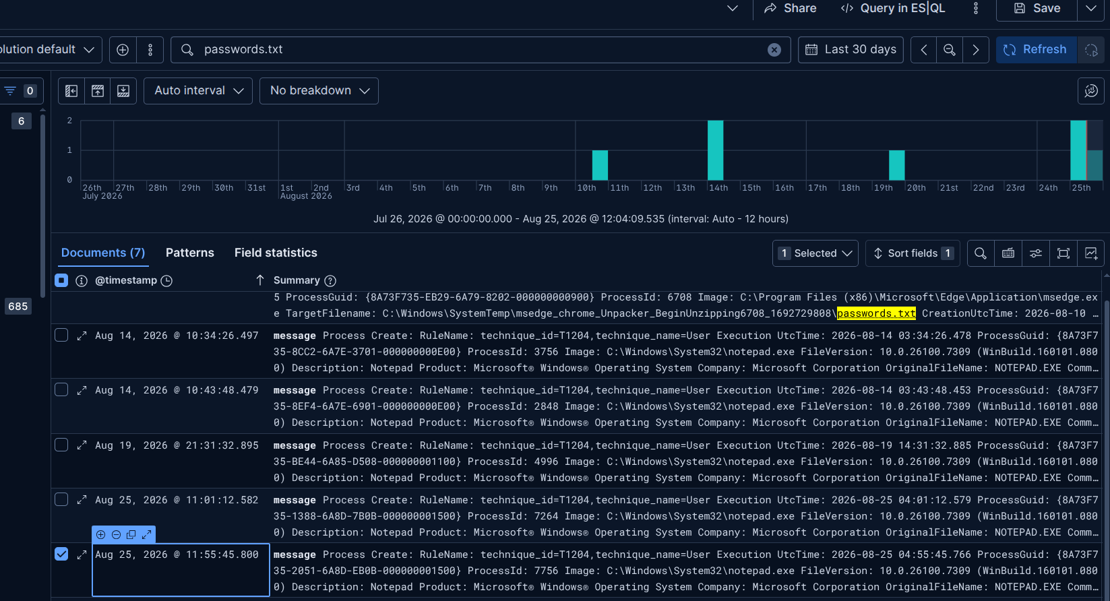
Figure 9: Searching for file accessing actions

The “Process Create” log lines being displayed in Figure 9 correspond to double-click action on the passwords.txt file. Since .txt files are associated with Notepad by default, this action launches notepad.exe process. These events are not particularly important in my case.

Explaining two different methods open the file to generate different events:
Method 1: double-click directly to the file passwords.txt, on the SIEM will show:

OriginalFileName: NOTEPAD.EXE
CommandLine: "C:\WINDOWS\system32\NOTEPAD.EXE" C:\Users\Administrator\Documents\passwords.txt
CurrentDirectory: C:\Users\Administrator\Documents\

=> In the figure 9, events with id 1 were generated by this action.

Method 2: Open notepad.exe first → open the file: At that time, event id = 1 only records the creation action of the notepad process. If we search for the string passwords.txt, we won’t find any events associated with that string. Some important artifacts we have:

OriginalFileName: NOTEPAD.EXE
CommandLine: "C:\WINDOWS\system32\notepad.exe"
CurrentDirectory: C:\Users\Administrator\

=> Therefore, correlating the events generated by method 2 can be more difficult!

Digression:
If a detection rule has custom fields configured in the highlighted fields section, the alert will display the fields that you specify in the Highlighted fields section. Otherwise, it will display predefined fields corresponding to the type of rule. The following two case illustrate as below:
kibana.alert.rule.type
Example 1: RDP Brute Force threshold rule’s alert
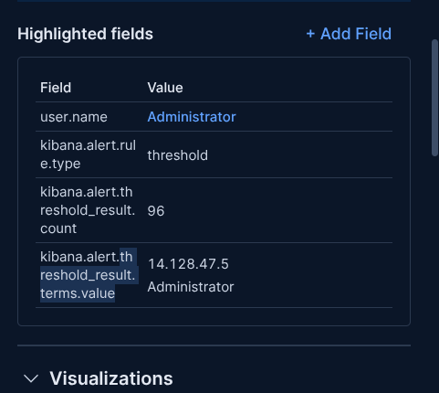
Figure 10: Highlighted fields in threshold rule

Example 2: Mythic Agent Alert
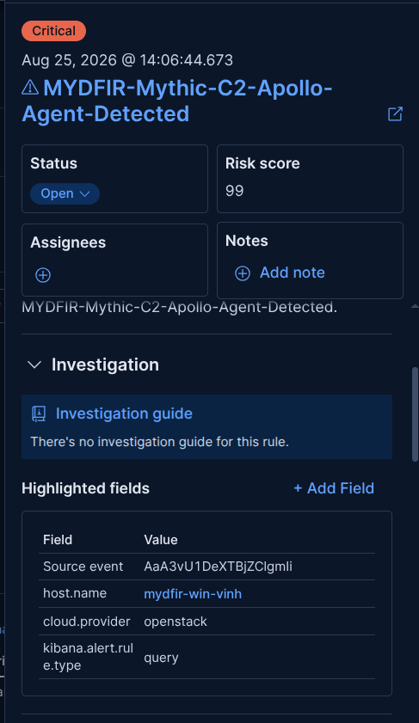
Figure 11: Highlighted fields in query rule
As you can see in the Figure 10 and 11, I didn’t specify any custom highlighted fields for either rule. The difference between them is as follow:
- For the threshold rule, the username and the source ip field are included in the highlighted fields. This helps us investigate easier as soon as we view the alert.
- For the query rule, those fields are not included. It only displays host name field that indicates the name of the target machine.

- Note: Có tải và chạy lại 2 lần file apollo (đã đổi tên thành mydfir-30.exe) vào lúc 14:06p ngày 25/08 để test điêu tra tấn công C2

When I turn on Windows Defender on the Windows machine and run the payload again, it will block malicious file and generate a log for this event:
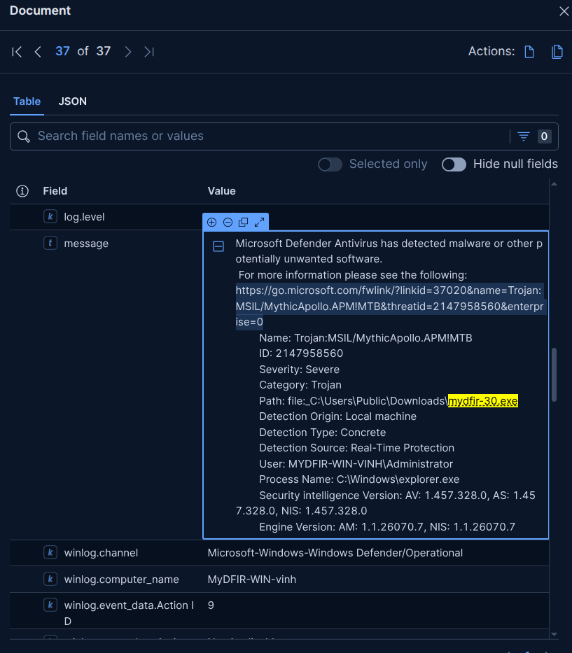
Figure 12: Log generated by Windows Defender
=> As soon as the log arrived at the SIEM system, the payload was deleted on the system.

I wondered if the SIEM could record every command sent from the attacker through the C2 channel, so I decided to execute several commands through Mythic Interface:
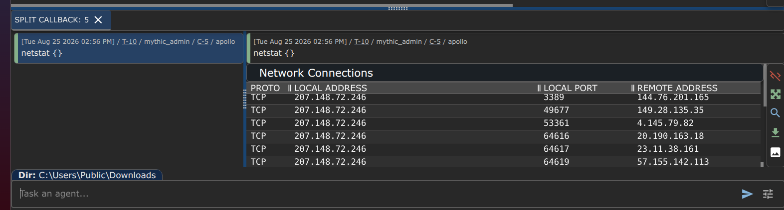
Figure 13: builtin command of the payload
I then searched the SIEM system for these commands, but I couldn’t find any events associated with the command I performed remotely.

Next, I will execute another command using shell + <command to run> from the Mythic Interface. Now, the result is still the same as when we ran ifconfig builtin above. I’ll then go to the SIEM system and search for the command I just ran. This time, I can see the command in the log right now.
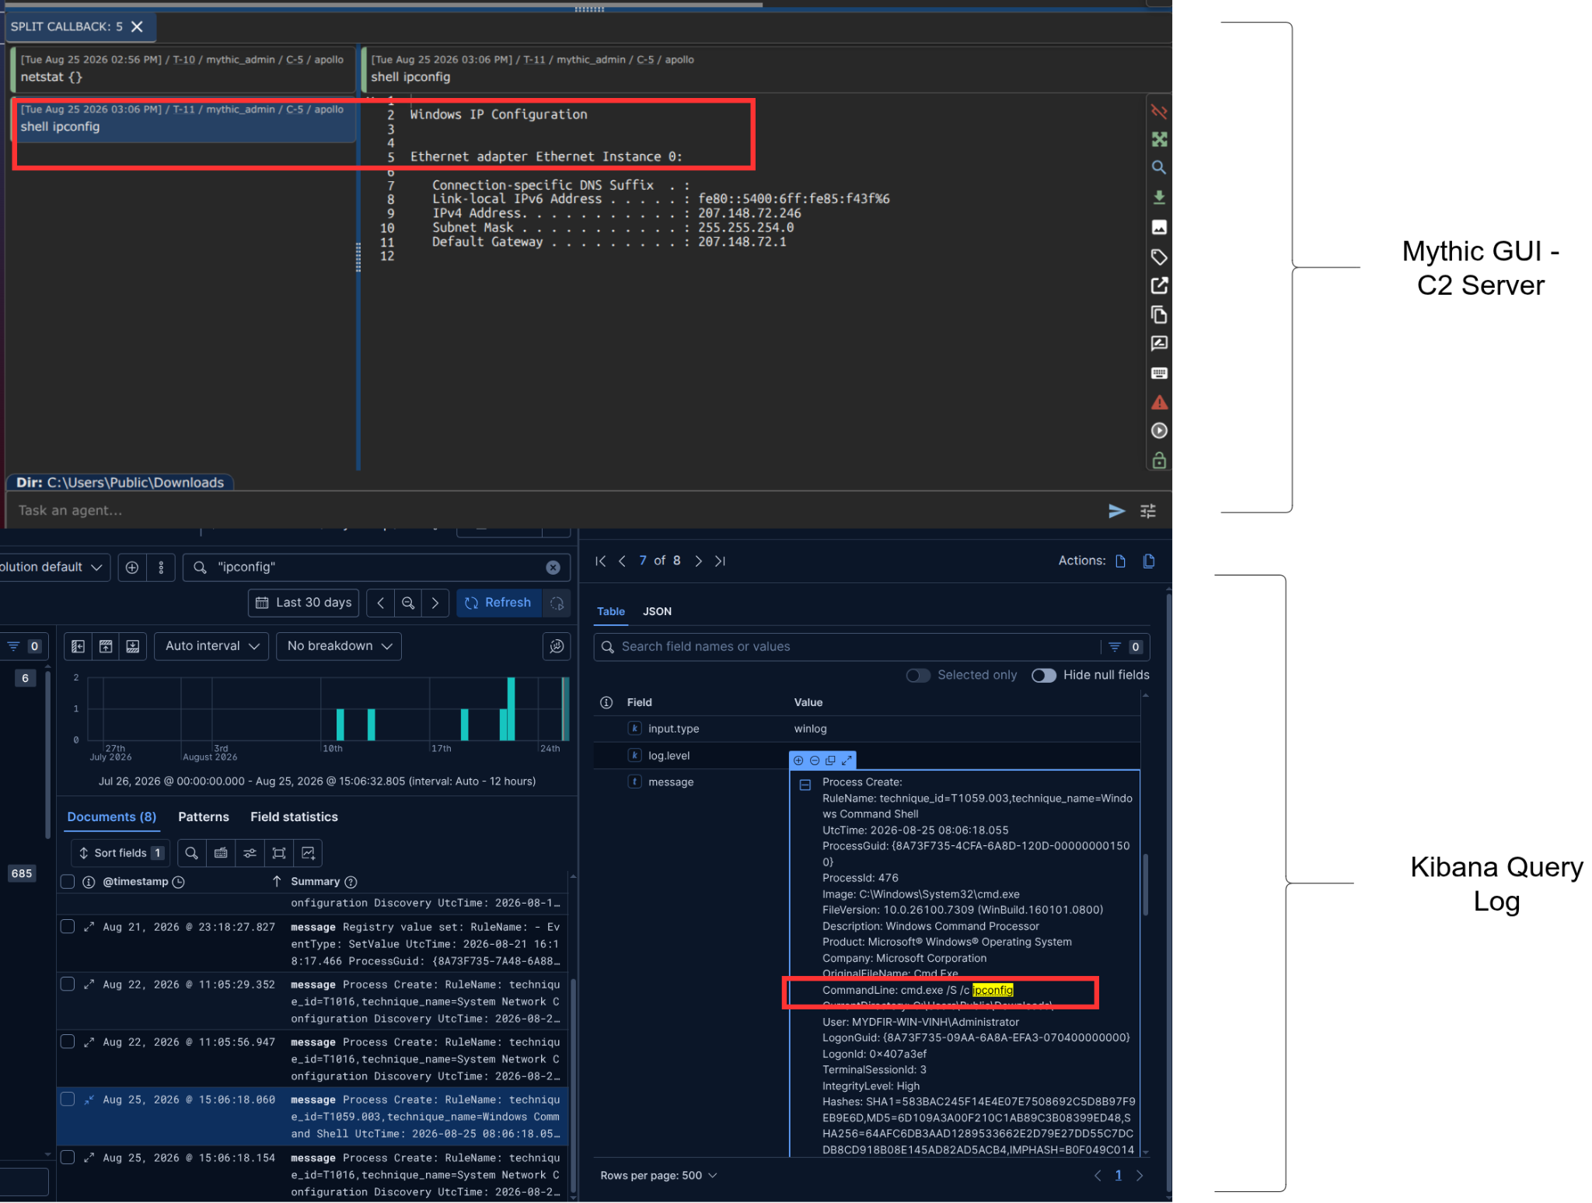
Figure 14: Run the command again with shell keyword
As shown in Figure 14, I found a document indicating the command we just ran. Full command line was displayed is cmd.exe /S /c ipconfig, you can view details in the link [1]

/c | Carries out the command specified by <string> and then exits the command processor.
/s | When used with /c or /k, triggers special non-parsing rules that strip the first and last quotes (") around the <string> but leaves the rest of the command unchanged.

In summary,
Một số lệnh chạy chính ngay trong shell của target machine or run “shell + <command>” từ giao diện của mythic GUI quản lý thì mới được ghi lại trong log. Còn các lệnh chạy trực tiếp như netstat, whoami.... thì phải packet level (capture pcap) mới có khả năng bắt được, nhưng thường bị mã hóa. (Lý do là khi chạy các command kia thì mặc định là các lệnh built-in của apollo agent code sẵn nó sẽ tự xử lý mà ko spawn process nào khác.)

* Bonus (Optional): Check if the “non-shell” commands could be captured through network traffic.
CONCLUSION
You can also use the RITA tool to improve C2 detection capability of your system. Real Intelligence Threat Analytics (R-I-T-A) is an open-source framework for detecting command and control communication through network traffic analysis. The RITA framework ingests Zeek logs in TSV or JSON format, or PCAPs converted to Zeek logs for analysis [3].

REFERENCES:
[1] https://learn.microsoft.com/en-us/windows-server/administration/windows-commands/cmd
[2] Sysmon Process Events: https://github.com/trustedsec/SysmonCommunityGuide/blob/master/chapters/process-events.md
[3] https://www.blackhillsinfosec.com/rita

